**Energy balanced reliable and effective clustering for underwater wireless sensor networks**

Arfa Saleem Roll no.2521334  
 BS.Software Engineering(5th semester)  
Government College University Faisalabad  
 ranaarfa864@gmail.com

**Abstract:**

The transmission of data in submerged wireless sensor networks demands higher power due to increased signal distance and energy loss along the route. Factors like acoustic interference from shadows and marine life, along with challenges such as multipath fading, significant path loss, and various interferences at greater depths, complicate communication. Variables like variable connection strength, low bandwidth, high salinity, pressure, temperature, sinkholes, and curved routes significantly impact energy efficiency, link quality, and packet delivery ratio (PDR). To address these issues, the Energy Balanced Reliable and Effective Clustering (EBREC) method was developed, focusing on intact data packet delivery and reducing transmission losses and PDR. EBREC's superiority was demonstrated by comparison with the following benchmarks: Alive Nodes (91%), PDR (97.6%), Throughput (10Mbps), Residual Energy (0.615 J), Consumed Energy (2.3 mJ), and Network Lifetime (1750 sec). EBREC demonstrated its efficacy in surmounting obstacles in submerged wireless networks by outperforming alternative techniques.

Underwater Wireless Sensor Networks (UWSNs) are made up of sensors and cars that are placed in sound-absorbing regions to work together to monitor and gather data. Interactive communication between nodes and ground-based stations is made possible by these networks. Challenges for UWSNs include low bandwidth, high propagation delay, media access control, routing, power consumption, and 3D topology. Due to the changing nature of the undersea environment, several parts of these difficulties remain unexplored despite a variety of approaches being presented to address them. Further research in these areas is crucial for further improvements in UWSNs. The paper conducts a survey focused on environmental factors, localization, media access control, routing protocols, and the impact of packet size on communication within UWSNs. It compares existing methodologies, highlighting their strengths and weaknesses to underscore new avenues for enhancing underwater sensor networks.

1. Introduction:

The potential for monitoring aquatic environments with underwater wireless sensor networks (UWSNs) is enormous.[1] Uses for UWSNs include gathering oceanographic data, detecting marine pollution, and monitoring aquatic habitats. Because radio transmission is limited in underwater environments, UWSNs use aural communication instead of radio waves, as do Terrestrial Wireless Sensor Networks (TWSNs).[2] Environmental elements that affect sensor nodes in UWSNs include noise, turbulence, water salinity, and signal attenuation. Nonetheless, the network's long-term viability is the most important issue with UWSNs. Because sensor nodes run exclusively on non-removable batteries, it is essential to optimize the network's energy usage to achieve longer endurance. Notable concerns include sinkholes, excessive energy consumption, propagation delays, and power changes between nodes that impact network longevity and connection. The main source of energy usage is inter-node data transport. Numerous strategies, such as radio optimization, data minimization, sleep/wake systems, energy-efficient routing, and battery depletion procedures, have been put forth to lessen this. Due to the increased energy requirements of radio transmission, energy-efficient routing is very important. Potential energy-efficient routing strategies in UWSNs[3-6] are being investigated using techniques such sink mobility mechanisms, relay node placement strategies, energy-aware routing, multi-path routing, clustering designs, and so on. The mobility of underwater sensor nodes, which usually move at speeds [7] of 2-3 m/sec due to underwater activities and environments, is one important difference between underwater and land-based sensor networks. Localization is a prerequisite for efficient data interpretation. [8-10] But many energy-efficient protocols that are already in use and were meant for stationary nodes become ineffective in underwater environments due to the mobility of nodes.[11-13] Well-known protocols that function well in static environments, such as Directed Diffusion, Gradient, Rumor Routing, TTDD, and SPIN, have difficulty keeping up with the quick changes in underwater network architecture.[14-16]

In multi-hop underwater networks, selecting the ideal packet size becomes essential as it affects latency, energy consumption, throughput efficiency, and resource utilization.[26] For better network performance, research highlights how important it is to choose the right packet size based on protocol features like provided load and bit error rate.[9] The study makes a substantial contribution by outlining the features of the deep and shallow oceans, describing how temperature affects acoustic communication, noise, errors, and protocols because of different environmental conditions. [27-29] It also goes over how routing protocols in UWSNs are categorized and contrasted in terms of latency, multipath routing, load balancing, energy usage, geographic data, communication overhead, and temporal complexity. [30-31] Additionally, data delivery ratios for single and multipath routing are compared, and the advantages and disadvantages of MAC protocols with respect to various topologies are evaluated. It delves deeply into the difficulties, procedures, and tactics involved in optimizing energy use, maximizing the use of available resources, and enhancing the sustainability and efficiency of underwater wireless sensor networks. [32-33]**Contribution:**

# The Energy Balanced Reliable and Effective Clustering (EBREC) technique improves energy efficiency, link quality, and packet delivery ratio (PDR) while addressing power requirements and handling fluctuations in auditory transmission. With its multilayer clustering routing method, EBREC extends the lifetime of the network by choosing the Cluster Head (CH) wisely and guarantees the delivery of entire packets of data. Part 2 of the study reviews the literature; Part 3 describes the network and energy model; Part 4 provides details about the EBREC algorithm; Part 5 offers UWSN performance measures; Part 6 includes the simulation environment and results; and Part 7 concludes with conclusions.

# **Literature Survey:**

## The studies addressing issues with underwater wireless sensor networks (UWSNs), such as underwater noise, channel attenuation, bandwidth constraints, acoustic wave speed, and network lifespan reduction, are assessed in this area. The main issue that affects network lifetime is the low battery capacity of nodes, which is the subject of much scientific research. Because data transmission uses a lot of energy, routing solutions are essential for controlling sensor node energy consumption. [17] Route selection plays a role in classifying UWSN routing protocols into two primary groups: localization-based and localization-independent. In particular, the study addresses energy-efficient protocols in UWSNs, with a focus on methods aimed at enhancing energy economy in the network environment while fulfilling data transmission goals.

**2. Related Work:**

Energy-efficient routing strategies have been established for Underwater Wireless Sensor Networks (UWSNs) by a number of studies, including Xiao et al. [25]. EECRP improves network performance by reducing needless data transit and electricity usage through the use of data fusion and evolutionary algorithms. Javaid et al suggested cooperative routing that considers reliability and distance, cutting down on network hops and using diversity approaches to transport data packets, however they ran into problems with energy leakage. By integrating fuzzy logic to cluster formation and path selection, Tavakoli et al. [18-19]

constructed a fuzzy-based Energy Efficient Clustering Routing protocol, improving packet delivery ratio. In order to create a proactive routing approach that could be adjusted to different network density, Khan et al looked at the least energy-consuming paths. [20]

## Nevertheless, the modification approach encountered difficulties due to unoccupied nodes impacting transmission. An optimization-based MCR routing technique was presented by Subramani et al. Paths are found by building clusters and utilizing optimization methods. While introducing ways to maintain the greatest number of adjacent neighbors during data transmission, Awais et al encountered problems with packet loss.[21] The EBREC algorithm was proposed in response to various challenges faced by other protocols, including interference, inefficiency, and energy depletion. It combines data fusion, genetic algorithms, and improved data aggregation and communication to improve network performance and energy efficiency in UWSNs. By lowering needless data transport and electricity consumption, EBREC increases network lifespan and improves overall quality; however, the lack of established benchmarks makes it difficult to assess and compare EBREC's efficacy against other protocols.[22]

#### **Propagation Phenomena of Underwater Sensor Networks**

## The reliability of underwater acoustic communication in the marine environment is affected by a variety of environmental conditions, making it complex. An extremely variable auditory channel is produced by these characteristics, which also include extended propagation delays, ambient noise, path loss, Doppler dispersion, and multipath effects. Acoustic communication is greatly impacted by the undersea environment, which differs between shallow and deep ocean areas. The acoustic channels in shallow ocean locations are more complex than those in deeper ocean regions because of strong temperature gradients, significant multipath effects, surface noise, and significant propagation delays. These unique features impact the main propagation parameters affecting acoustic communication in underwater environments, defining the difficulties and complexities involved in sending signals underwater.

##### **3.1 Path Loss:**

## Transmission delays and power loss in acoustic communication are impacted by three types of energy loss in underwater sound propagation: geometric spreading (spherical and cylindrical), attenuation from energy conversion into heat absorbed by the medium, and scattering from deviations in signal path or angle [25, 34].

##### **3.2. Noise**

## Underwater noise is the result of a variety of human- caused disruptions, including machinery, shipping, military activity, and background noise from turbulence, wind, and temperature impacts. [35] Natural acoustic communication is disrupted by human-produced noise, while ambient noise, which is a combination of unknown sources, comprises thermal noise proportionate to the communication frequency, wind-induced bubbles, shipping activity, and low-frequency noise generated by turbulence. [36]

## **Proposed network and energy model:**

For Underwater Wireless Sensor Networks (UWSNs), a three-dimensional (3D) layout is the main emphasis of the proposed Energy Balanced Reliable and Effective Clustering (EBREC) network model, which takes sink locations, forwarder node selection, and sensor node distribution into account. Sinks at the top and bottom of the network communicate via radio and acoustic signals, respectively. The cylinder-shaped network area defines the transmission range of the sensor node, 'r.' The cylindrical structure is segmented into layers, and each layer's height is different to compensate for transmission loss caused by water pressure. Within each network block, clusters are formed, and Cluster Heads (CHs) are assessed according to fitness, closeness, and residual energy.

Communication costs are decreased through cluster-to-cluster uniform node distribution and cluster-to-cluster adaptive broadcast ranges. The suggested technique highlights the robustness of vertical auditory transmission by enabling data transfer both within and between clusters vertically. Data is collected from lower-level CHs by means of gateway nodes on each level. Energy is saved by implementing sleep-wake cycles, which maintain one active node per cluster for sensing while the remaining nodes sleep lightly. Within each cluster, the most energy-efficient node placement—designated as the active node—is determined via a methodical evaluation. Cluster leaders control other nodes' sleep signals and assign sensing responsibilities to specific nodes. The system computes several possible paths using a multilayer protocol, then chooses the most effective method for data transmission.

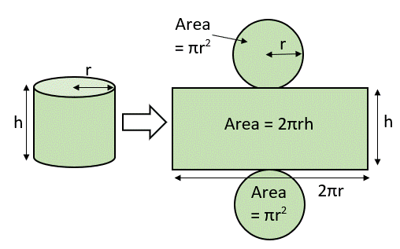

The suggested technique uses a wake-up scheduling algorithm to wake up nodes in sleep mode and activate them along the most effective path. Higher-level CHs receive data gathered from different cluster nodes and forward it to the sink. Iterations are used to find the best route, which maximizes the effectiveness of data transfer.

To summarize, the EBREC network model leverages gateway nodes for data gathering and relay, introduces a 3D layout, clusters nodes, controls sleep-wake cycles, and emphasizes vertical acoustic transmission. In UWSNs, this strategy seeks to increase energy efficiency, improve data transmission paths, and extend network lifetime.

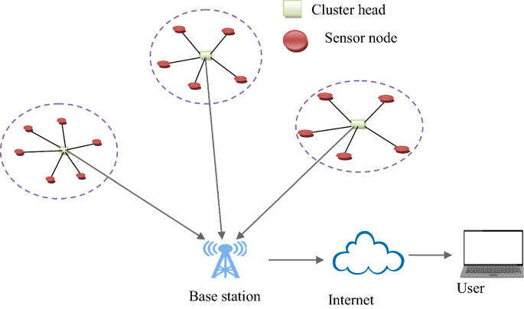

6 Cluster Head Selection.

. 3D cylindrical surface region.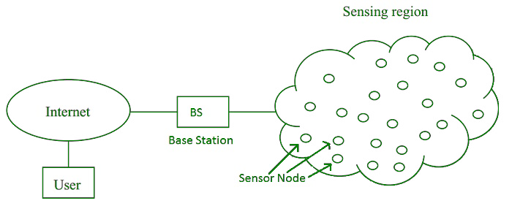

General Architecture of UWSN.. Proposed EBREC algorithm :

of Underwater Wireless Sensor During the cluster construction phase Networks (UWSNs), the proposed EBREC algorithm seeks to optimize energy consumption. Below is an overview of the steps in the algorithm:

Network Initialization: The algorithm starts by forming a cylinder-shaped network region with specified height (h) and radius (r).

Iteration of Cylinders: For every cylinder in the network:

The sensor node (k) that minimizes the distance between node k and the cluster head (C) and maximizes residual energy (R.E.) is found in line 3.

Neighborhood Recognition:

For every node (t) in node k's neighborhood:

Lines 5–6 designate node t as a child node of cluster head k after verifying that it is not already a part of any cluster.

5. Performance metrics of UWSN

Energy Use at the Node Level:

The equation E=T×P, where T is the time length, P is the power consumption rate, and E is the energy consumption, can be used to estimate the energy consumption (E) at the node level. Both active and idle power usage are included in this power consumption rate.

Network-Scope Energy Usage:

It is possible to examine the network's overall energy consumption (Enet) by taking into account several components, including data processing (Eproc), sensing (Esens), transmission (Etrans), and reception (Erecv).

Elements Affecting Energy Usage:

Energy consumption in UWSNs is influenced by a number of elements, including mobility, sensing, data processing, and node communication. Energy usage is also greatly impacted by communication modulation, data rate, and transmission distance.

Data Transmission Energy Consumption:

The formula for calculating the energy consumption of data transmission over a distance (E) is = ⿰ ⿰ ⁰ + ⁰ ×d ¿  2 E=E  elec​+E  amp​Π ×d ¿}. In this formula, the node electronics energy consumption is represented by ⁽ ⁽ ⁽ 㿽 ⁽  E elec  , the amplifier energy consumption is represented by Π ⁰ ⁰ ⁰  E amp​ , and Π2 d 2 denotes signal attenuation over distance in the underwater environment.

The amount of energy used by packets:

The energy required to transmit the content (Edata) and header (Eheader) of a packet (Etx) is involved.

Energy is needed to process the received signal (Eelec), header (Eheader), and packet (Erx).

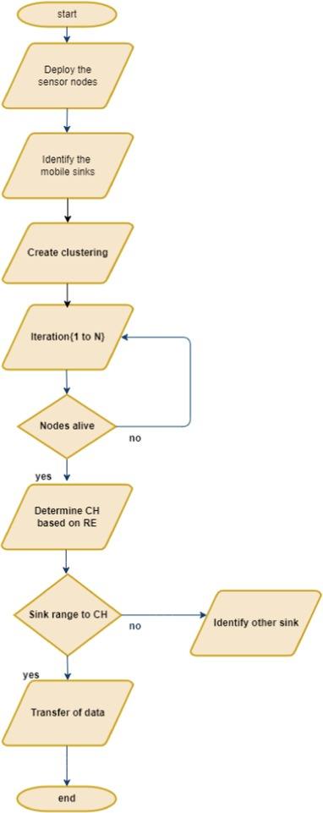

1. 8. Number of cluster heads analysis

An essential component of underwater wireless sensor networks is the study of the number of cluster heads, which aids in determining how well the network's clustering algorithms are working. In UWSNs, clustering is a widely used strategy that involves selecting cluster heads to connect with the sink node and organizing nodes into clusters to enhance network performance and lower energy usage.

1. NCH ¼ sqrtðNÞ ð17\
2. where N is the total number of nodes in the network and NCH is the number of cluster heads.
3. This formula makes the assumption that each cluster has an equal number of nodes and that the nodes are dispersed evenly throughout the network. In actuality, the clustering technique might designate several
4. Simulation environment and results of experiment
5. The objective of this study is to evaluate the efficacy of the Energy Balanced Reliable and Effective Clustering (EBREC) method in MATLAB with respect to residual energy-based metrics in Underwater Wireless Sensor Networks (UWSNs). By using less energy, this multilayer clustering-based method aims to increase the lifespan of UWSNs. The algorithm's efficiency is validated and benchmarked by comparison with state-of-the-art approaches. Through this evaluation, scientists hope to ascertain how well EBREC maximizes energy efficiency and prolongs the life of the network. Because of its versatility in simulating complex algorithms for UWSNs and its strong computational capabilities, MATLAB is the platform used for this study. By contrasting EBREC with current approaches, it will be possible to determine where it is superior or where it falls short, which will be important information for UWSN adoption in the future.
6. In the end, the objective is to position EBREC as a viable option for UWSNs, providing a way to drastically cut down on energy usage, improve network stability, and increase the operational lifetime of underwater sensor networks—possibly resolving important issues in underwater environments with limited energy.

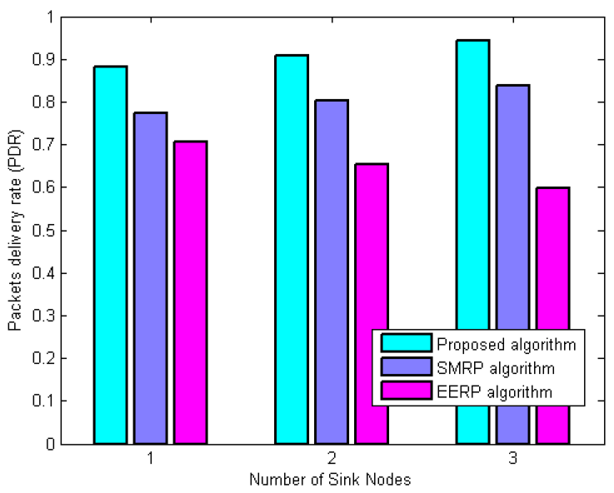

Underwater Wireless Sensor Networks (UWSNs) with varying node densities, network sizes, and communication ranges are evaluated in order to determine how effective the clustering algorithms are. Finding a balance between network coverage, energy usage, and communication overhead is necessary to optimize data transmission efficiency. While sending fewer packets could improve these features but may jeopardize network coverage and reliability, sending a high number of packets to the sink node may raise overhead and energy usage. The efficiency of EBREC's fitness functions is what makes it effective, and Fig. 9 illustrates how this likely leads to higher data packet success rates. By storing node residual energy (RE), these features increase the number of data packets that successfully arrive at their intended destination and lower the number of transmission dropouts. When compared to other techniques such as EAMC, MCBOR, EGRC, and BEEC, EBREC performs better. This is especially evident in Table 3, which shows a greater quantity of packets that are successfully transferred to the sink node.

Overall, the review highlights the benefits of EBREC, particularly its optimized fitness functions that reduce transmission dropouts and increase data packet success rates. These results highlight EBREC as a viable UWSN solution, as it outperforms current approaches in terms of packet transmission success to the sink node.

Conclusion:

Rapid energy depletion between nodes is a common concern for Underwater Wireless Sensor Networks (UWSNs), affecting network lifespan and overall performance. In order to overcome this problem, the Energy Balanced Reliable and Effective Clustering (EBREC) algorithm was developed with the goal of increasing the network's lifetime.

Because UWSNs have faster vertical communication, EBREC focuses on using a bottom-up routing strategy to extend the network's active duration. When the residual energy of the cluster head (CH) reaches a predetermined threshold, it dynamically modifies the CH roles to reduce energy strain. Notably, to control water pressure and guarantee effective transmissions, modifications were made to the height distribution of the cylinder. It is expected that these architectural modifications will greatly increase the network's longevity. The simulation results demonstrate how well EBREC performs in comparison to alternative techniques. Measures like Packet Delivery Ratio (97.6%), Network Lifetime (1750 sec), Residual Energy (0.615 J), Consumed Energy (2.3 mJ), Throughput (10Mbps), and Number of Alive Nodes (91%) demonstrate the efficacy of EBREC.

The investigation highlights important directions for further research and highlights the requirement for routing algorithms that improve service quality. Further research is advised to tackle the difficulties presented by changing undersea conditions, with a focus on security measures for safe clustered routing protocols.

In this particular situation, funding, ethical approval, consent to participate, and consent to publish are considered non-applicable. However, the work also points to intriguing directions for future research, especially in terms of creating routing algorithms that take into account UWSN properties and guaranteeing secure communication protocols in submerged environments.

Declaration of Competing Interest

The authors confirm that there are no known financial conflicts of interest or personal affiliations that could slant the work published in this paper, guaranteeing the objectivity and integrity of the study results.

Acknowledgments:

The authors would like to thank the anonymous reviewers for their insightful reviews, insightful remarks, and helpful suggestions that improved the caliber and rigor of this research study. Their helpful criticism has greatly improved the work's content and bolstered its scholarly contribution.

References:

[1] C.V. Ravikumar, A. Rajesh, G. Pau, Underwater Wireless Sensor Network Performance Analysis Using Diverse Routing Protocols, J. Sens. Actuator Netw. 11 (2022) 64, https://doi.org/ 10.3390/jsan11040064.

[2] Jouhari, M,; Ibrahimi,; M, Tembine, H; and Ben-Othman, J,, ‘‘Underwater wireless sensor networks: A survey on enabling technologies, localization protocols, and Internet of underwater things’,’ IEEE, Access 7 (2019) 96879–96899.

[3] R. Anbazhagan, R.C. Venkata, F. Arena, G. Pau, Investigation and Numerical Simulation of the Acoustic Target Strength of the Underwater Submarine Vehicle, Inventions 7 (2022) 111, <https://doi.org/10.3390/inventions704011>.

[4] H. Liang, S. Yang, Research on routing optimization of WSNs based on improved LEACH protocol, EURASIP Journal on Wireless Communications and Networking, Springer 194 (2019).

[5] Jianying Zhu, Yougan Chen , Xiang Sun , Jianming Wu, Zhenwen Liu, Xiaomei Xu. ‘‘ECRKQ: Machine Learning-Based

EnergyEfficient Clustering and Cooperative Routing for Mobile Underwater Acoustic Sensor Networks”, IEEE Access, 2021.

[6] P.A. Shelar, G.R. Mahalle, H.R. Shinde, M.A. Bhapkar, Tefera., Performance-Aware Green Algorithm for Clustering of Underwater Wireless Sensor Network Based on Optical Signal-to-Noise Ratio, Math. Probl. Eng. (2022).

[7] I. Ullah, J. Chen, X. Su, C. Esposito, C. Choi, ‘Localization and detection of targets in underwater wireless sensor using distance and angle based algorithms’, IEEE Access 7 (2019) 45693– 45704.

[8] A. Ranjha, G. Kaddoum, M. Rahim, K. Dev, URLLC in UAVenabled multicasting systems: A dual time and energy minimization problem using UAV speed, altitude and beamwidth, Comput. Commun. 187 (2022) 125–133.

[9] H.K. Narsani, K. Dev, F.H. Memon, N.M.F. Qureshi, Leveraging UAV-assisted communications to improve secrecy for URLLC in 6G systems, Digital Communications and Networks. (2022).

[10] M. Asif, A. Ihsan, W.U. Khan, A. Ranjha, S. Zhang, S.X. Wu, Energy-Efficient Backscatter-Assisted Coded CooperativeNOMA for B5G Wireless Communications, IEEE Transactions on Green Communications and Networking. (2022).

[11] K. Sathish, M. Hamdi, R. Chinthaginjala, G. Pau, A. Ksibi, R. Anbazhagan, M. Abbas, M. Usman, Reliable Data Transmission in Underwater Wireless Sensor Networks Using a Cluster-Based Routing Protocol Endorsed by Member Nodes, Electronics 12 (2023) 1287, https://doi.org/10.3390/ electronics12061287.

[12] I.A. Hayder, S.N. Khan, F. Althobiani, M. Irfan, M. Idrees, S. Ullah, F. Alsaaq, A. Glowacz, I. Goldasz, M. Tomczyk, R. Martis, Towards Controlled Transmission: A Novel PowerBased Sparsity-Aware and Energy-Efficient Clustering for Underwater Sensor Networks in Marine Transport Safety, Electronics 10 (2021) 854, https://doi.org/10.3390/ electronics10070854.

[13] K. Sathish, R.C. Venkata, R. Anbazhagan, G. Pau, Review of Localization and Clustering in USV and AUV for Underwater Wireless Sensor Networks, Telecom 4 (2023) 43–64, https://doi. org/10.3390/telecom4010004.

[14] Asadi Srinivasulu, Anand Kumar Gupta, ‘‘Performance Analysis of Underwater Wireless Sensor Network by Deploying FTP, CBR, and VBR as Applications”, Journal of Computer Networks and Communications, vol. 2022, Article ID 7143707, 30 pages, 2022. <https://doi.org/10.1155/2022/7143707>.

[15] A. Rajesh, Olutayo Oyeyemi Oyerinde, ‘‘Performance and Improvement Analysis of the Underwater WSN Using a Diverse Routing Protocol Approach”, Journal of Computer Networks and Communications, vol. 2022, Article ID 9418392, 19 pages, 2022. <https://doi.org/10.1155/2022/9418392>.

[16] Pasala Gopi, Pinni Srinivasa Varma, Ch Naga Sai Kalyan, C. V. Ravikumar, Asadi Srinivasulu, Bhimsingh Bohara, A. Rajesh, Mohd Nadhir Bin Ab Wahab, K. Sathish, ‘‘Dynamic Behavior and Stability Analysis of Automatic Voltage Regulator with Parameter Uncertainty”, International Transactions on Electrical Energy Systems, vol. 2023, Article ID 6662355, 13 pages, 2023. <https://doi.org/10.1155/2023/6662355>.

[17] L. Yan, Y. He, Z. Huangfu, An Uneven Node Self-Deployment Optimization Algorithm for Maximized Coverage and Energy Balance in Underwater Wireless Sensor Networks, Sensors 21 (2021) 1368, <https://doi.org/10.3390/s21041368>.

[18] X. Xiao, H. Huang, W. Wang, ‘Underwater wireless sensor networks: An energy-efficient clustering routing protocol based on data fusion and genetic algorithms’, Appl. Sci. 11 (1) (Dec. 2020) 312.

[18] N. Javaid, U. Shakeel, A. Ahmad, N. Alrajeh, Z.A. Khan, N. Guizani, DRADS: Depth and reliability aware delay sensitive cooperative routing for underwater wireless sensor networks, Wirel. Netw 25 (2) (2019) 777–789.

[19] J. Tavakoli, N. Moghim, A. Leila, F. Pasandideh, ‘A fuzzy based energy efficient clustering routing protocol in underwater sensor networks’, J. Commun. Eng. 9 (1) (2020) 154–167.

[20] Z.A. Khan, M. Awais, T.A. Alghamdi, A. Khalid, A. Fatima, M. Akbar, N. Javaid, Region aware proactive routing approaches exploiting energy efficient paths for void hole avoidance in underwater WSNs, IEEE Access 7 (2019) 140703–140722.

[21] N. Subramani, P. Mohan, Y. Alotaibi, S. Alghamdi, O.I. Khalaf, ‘An efficient Metaheuristic-based clustering with routing protocol for underwater wireless sensor networks’, Sensors 22 (2) (Jan. 2022) 415.

[22] M. Awais, Z.A. Khan, N. Javaid, A. Mateen, A. Rasul, F. Hassan, Cluster-based routing protocols with adaptive transmission range adjustment in UWSNs, in: International Conference on Emerging Internetworking, Data & Web Technologies, Springer, 2019, pp. 528–539

[23] Wang, K. Ben, H. Lin, M. Zuo, F. Zhang, EP-ADTA: Edge Prediction-Based Adaptive Data Transfer Algorithm for Underwater Wireless Sensor Networks (UWSNs), Sensors 22 (2022) 5490, <https://doi.org/10.3390/s22155490>

1. [24 ]N.-S. N. Ismail, L. A. Hussein, and S. H. S. Ariffin, “Analyzing the performance of acoustic channel in underwater wireless sensor network(UWSN),” in Proceedings of the Asia Modelling Symposium 2010: 4th International Conference on Mathematical Modelling and Computer Simulation, AMS2010, pp. 550–555, Malaysia, May 2010.

View at: [Google Scholar](https://scholar.google.com/scholar_lookup?title=Analyzing%20the%20performance%20of%20acoustic%20channel%20in%20underwater%20wireless%20sensor%20network(UWSN)&author=N.-S.%20N.%20Ismail&author=L.%20A.%20Hussein&author=S.%20H.%20S.%20Ariffin)

1. [25] L. Liu, S. Zhou, and J. H. Cui, “Prospects and problems of wireless communication for underwater sensor networks,” Wireless Communications and Mobile Computing, vol. 8, no. 8, pp. 977–994, 2008.

View at: [Publisher Site](https://doi.org/10.1002/wcm.654) | [Google Scholar](https://scholar.google.com/scholar_lookup?title=Prospects%20and%20problems%20of%20wireless%20communication%20for%20underwater%20sensor%20networks&author=L.%20Liu&author=S.%20Zhou&author=J.%20H.%20Cui&publication_year=2008)

1. [26]--J. Kong, M. Gerla, and S. Zhou, Challenges: Building Scalable and Distributed Underwater Wireless Sensor Networks (UWSNs) for Aquatic Applications, 2005.
2. [27] S. Basagni, C. Petrioli, R. Petroccia, and M. Stojanovic, “Optimized packet size selection in underwater wireless sensor network communications,” IEEE Journal of Oceanic Engineering, vol. 37, no. 3, pp. 321–337, 2012.

View at: [Publisher Site](https://doi.org/10.1109/JOE.2012.2197271) | [Google Scholar](https://scholar.google.com/scholar_lookup?title=Optimized%20packet%20size%20selection%20in%20underwater%20wireless%20sensor%20network%20communications&author=S.%20Basagni&author=C.%20Petrioli&author=R.%20Petroccia&author=M.%20Stojanovic&publication_year=2012)

1. [28] S. Basagni, C. Petrioli, R. Petroccia, and M. Stojanovic, “Optimizing network performance through packet fragmentation in multi-hop underwater communications,” in Proceedings of the OCEANS'10 IEEE Sydney, OCEANSSYD 2010, pp. 1–7, Australia, May 2010.

View at: [Google Scholar](https://scholar.google.com/scholar_lookup?title=Optimizing%20network%20performance%20through%20packet%20fragmentation%20in%20multi-hop%20underwater%20communications&author=S.%20Basagni&author=C.%20Petrioli&author=R.%20Petroccia&author=M.%20Stojanovic)

1. [29] S. Basagni, C. Petrioli, R. Petroccia, and M. Stojanovic, “Choosing the packet size in multi-hop underwater networks,” in Proceedings of the OCEANS'10 IEEE Sydney, OCEANSSYD 2010, pp. 1–9, Australia, May 2010.

View at: [Google Scholar](https://scholar.google.com/scholar_lookup?title=Choosing%20the%20packet%20size%20in%20multi-hop%20underwater%20networks&author=S.%20Basagni&author=C.%20Petrioli&author=R.%20Petroccia&author=M.%20Stojanovic)

1. [30] M. Ayaz, L. T. Jung, A. Abdullah, and I. Ahmad, “Reliable data deliveries using packet optimization in multi-hop underwater sensor networks,” Journal of King Saud University - Computer and Information Sciences, vol. 24, no. 1, pp. 41–48, 2012.

View at: [Publisher Site](https://doi.org/10.1016/j.jksuci.2011.09.001) | [Google Scholar](https://scholar.google.com/scholar_lookup?title=Reliable%20data%20deliveries%20using%20packet%20optimization%20in%20multi-hop%20underwater%20sensor%20networks&author=M.%20Ayaz&author=L.%20T.%20Jung&author=A.%20Abdullah&author=I.%20Ahmad&publication_year=2012)

1. [31] N. Li, J.-F. Martínez, J. M. M. Chaus, and M. Eckert, “A survey on underwater acoustic sensor network routing protocols,” Sensors, vol. 16, no. 3, p. 414, 2016.

View at: [Google Scholar](https://scholar.google.com/scholar_lookup?title=A%20survey%20on%20underwater%20acoustic%20sensor%20network%20routing%20protocols&author=N.%20Li&author=J.-F.%20Mart%C3%ADnez&author=J.%20M.%20M.%20Chaus&author=M.%20Eckert&publication_year=2016)

1. [32] M. Faheem, G. Tuna, and V. C. Gungor, “QERP: Quality-of-Service (QoS) Aware Evolutionary Routing Protocol for Underwater Wireless Sensor Networks,” IEEE Systems Journal, 2017.

View at: [Google Scholar](https://scholar.google.com/scholar_lookup?title=QERP%3A%20Quality-of-Service%20(QoS)%20Aware%20Evolutionary%20Routing%20Protocol%20for%20Underwater%20Wireless%20Sensor%20Networks&author=M.%20Faheem&author=G.%20Tuna&author=V.%20C.%20Gungor&publication_year=2017)

1. [33] Zidi, F. Bouabdallah, and R. Boutaba, “Routing design avoiding energy holes in underwater acoustic sensor networks,” Wireless Communications and Mobile Computing, vol. 16, no. 14, pp. 2035–2051, 2016.

View at: [Publisher Site](https://doi.org/10.1002/wcm.2666) | [Google Scholar](https://scholar.google.com/scholar_lookup?title=Routing%20design%20avoiding%20energy%20holes%20in%20underwater%20acoustic%20sensor%20networks&author=C.%20Zidi&author=F.%20Bouabdallah&author=R.%20Boutaba&publication_year=2016)

[34] I. F. Akyildiz, D. Pompili, and T. Melodia, “Underwater acoustic sensor networks: research challenges,” Ad Hoc Networks, vol. 3, no. 3, pp. 257–279, 2005. View at: [Publisher Site](https://doi.org/10.1016/j.adhoc.2005.01.004) | [Google Scholar](https://scholar.google.com/scholar_lookup?title=Underwater%20acoustic%20sensor%20networks%3A%20research%20challenges&author=I.%20F.%20Akyildiz&author=D.%20Pompili&author=T.%20Melodia&publication_year=2005)

[35] D. H. Cato, “Ocean ambient noise: Its measurement and its significance to marine animals,” in Proceedings of the Conference on Underwater Noise Measurement, Impact and Mitigation, pp. 1–9, Institute of Acoustics, Southampton, UK, 2008.

View at: [Google Scholar](https://scholar.google.com/scholar_lookup?title=Ocean%20ambient%20noise%3A%20Its%20measurement%20and%20its%20significance%20to%20marine%20animals&author=D.%20H.%20Cato)

[36] E. J. Harland, SAS. Jones, and T. Clarke, “SEA 6 Technical report: Underwater ambient noise,” A report by QinetiQ as part of the UK Department of Trade and Industrys offshore energy Strategic Environmental Assessment programme, 2005.

View at: [Google Scholar](https://scholar.google.com/scholar_lookup?title=SEA%206%20Technical%20report%3A%20Underwater%20ambient%20noise&author=E.%20J.%20Harland&author=SAS.%20Jones&author=T.%20Clarke&publication_year=2005)